Experiment No. : 1

Title: Implementation of Array of Structure

Batch: B1 Roll No.: 1914078 Experiment No.: 1

Aim: Implementing a C program to create a roll call list of a class using array of structure. It have the details of students as roll number and name. Program should support following operations.
- Insert
- Delete
- Search
- Display
___________________________________________________________________________

Resources needed: Turbo C/C++ editor and C compiler (Online/Offline)
___________________________________________________________________________

Theory

- Arrays in C

Examples

- Structures in C

Examples

- Array of Structure

Examples

- Functions and Function signature

Examples
___________________________________________________________________________

Algorithm :
Program should have functions to add new student record, display all records, search a record and delete a record as per following methods and their signatures.
- Insert() – inserts(append) a new student record.

if (count != 10)
//Accept values and storing
count++
else
//Array is full so cannot add more

- Delete() - delete the record of the player based on if the entered name player was found and array was not empty.

if (count != 0)
char delname[50] //Accepts player name to delete record
i=0
while( strcmp(p[i],delname) != 0)
if( i<count )
i++
else
break //We have found the value
if ( i<=count )
//No such value found
for ( i; i<count; i++)
p[i] = p[i+1]
//Pulling other elements ahead
count—
else
//Player not found
else
//Array is empty

- Search() – Search for the player based on return the name of the player if name is found and array is not empty

if (count != 10)
char delname[50] //Accepts player name to delete record
i=0
while( strcmp(p[i],delname) != 0)
if( i<count )
i++
else
break //We have found the value
if(i==count)
//Element Not Found
else
//Element found and displays that record

- Display() – Display the list of players in the sorted format.

if (count != 0)
for i=0; i<count; i++)
for j=0;j<count-i;j++
//Swaping descending order based on
// avg , 100s,50s,strikeRate,highscore,name

Code:
#include <stdio.h>
#include <string.h>
#include <math.h>
#include <stdlib.h>

#include <ctype.h>
// tolower() method left to implement or try strcmpi()

struct player
{
char name[50];
int fifties, hundreds, highScore;
float avg, strikeRate;
} p[10];
int count = 0;
void insert();
void delete ();
void display();
void search();

int main()
{
int ch = 0;
printf("\n===== Stack operations using linked list =======");
while (ch != 5)
{
printf("\n\n1. Insert");
printf("\n2. Delete");
printf("\n3. Search");
printf("\n4. Display");
printf("\n5. Exit");
printf("\nEnter your choice from 1-5: ");
scanf("%d", &ch);
switch (ch)
{
case 1:
insert();
break;
case 2:
delete ();
break;
case 3:
search();
break;
case 4:
display();
break;
case 5:
break;
default:
printf("\nEnter your choice from 1-3 only");
break;
}
}
printf("\nThank you");
return 0;
}
void insert()
{
if (count != 10)
{
printf("\nInsert a new element : ");
printf("\nName : ");
scanf("%s", p[count].name);
printf("Fifties : ");
scanf("%d", &p[count].fifties);
printf("Hundreds : ");
scanf("%d", &p[count].hundreds);
printf("HighScore : ");
scanf("%d", &p[count].highScore);
printf("Average : ");
scanf("%f", &p[count].avg);
printf("Strike Rate : ");
scanf("%f", &p[count].strikeRate);
printf("\nAdded a new element");
count++;
}
else
{
printf("\nArray is Full");
}
}
void delete ()
{
if (count != 0)
{
char delname[50];
int i = 0;
printf("\nEnter name of player to be deleted\n");
scanf("%s", delname);
while (strcmp(p[i].name, delname) != 0)
{
if (i < count)
{
i++;
}
else
{
break;
}
}
if (i <= count)
{
for (i; i < count; i++)
{
p[i] = p[i + 1];
}
count--;
printf("\n\nRecord Deleted!");
}
else
{
printf("\n\nPlayer not found");
}
}
else
{
printf("\nArray is Empty");
}
}
void search()
{
if (count != 0)
{
char ch[50];
int i = 0, choice;
printf("\nEnter name of player\n");
scanf("%s", ch);
while (strcmp(p[i].name, ch) != 0)
{
if (i < count)
{
i++;
}
else
{
break;
}
}
if (i == count)
{
printf("No such element here!");
}
else
{
printf("Name\t 50s\t 100s\t avg\tstrikeRate highScore\n");
printf("%-10s %-5d %-8d %-8.2f %-8.2f %-8d\n", p[i].name, p[i].fifties, p[i].hundreds, p[i].avg, p[i].strikeRate, p[i].highScore);
}
}
else
{
printf("\nArray is Empty");
}
}
void display()
{
struct player temp;
if (count != 0)
{

for (int j = 0; j < count; j++)
{
for (int i = 0; i < count - j; i++)
{
if (p[i].avg < p[i + 1].avg)
{
temp = p[i];
p[i] = p[i + 1];
p[i + 1] = temp;
}
else if (p[i].avg == p[i + 1].avg && p[i].fifties < p[i + 1].fifties)
{
temp = p[i];
p[i] = p[i + 1];
p[i + 1] = temp;
}
else if (p[i].avg == p[i + 1].avg && p[i].fifties == p[i + 1].fifties && p[i].hundreds < p[i + 1].hundreds)
{
temp = p[i];
p[i] = p[i + 1];
p[i + 1] = temp;
}
else if (p[i].avg == p[i + 1].avg && p[i].fifties == p[i + 1].fifties && p[i].hundreds == p[i + 1].hundreds && p[i].strikeRate < p[i + 1].strikeRate)
{
temp = p[i];
p[i] = p[i + 1];
p[i + 1] = temp;
}
else if (p[i].avg == p[i + 1].avg && p[i].fifties == p[i + 1].fifties && p[i].hundreds == p[i + 1].hundreds && p[i].strikeRate == p[i + 1].strikeRate && p[i].highScore < p[i + 1].highScore)
{
temp = p[i];
p[i] = p[i + 1];
p[i + 1] = temp;
}
else if (p[i].avg == p[i + 1].avg && p[i].fifties == p[i + 1].fifties && p[i].hundreds == p[i + 1].hundreds && p[i].strikeRate == p[i + 1].strikeRate && p[i].highScore == p[i + 1].highScore)
{
int cmp = strcmp(p[i].name, p[i + 1].name);
if (cmp > 0)
{
temp = p[i];
p[i] = p[i + 1];
p[i + 1] = temp;
}
}
}
}
printf("Name\t 50s\t 100s\t avg\tstrikeRate highScore\n");
for (int i = 0; i < count; i++)
{
printf("%-10s %-5d %-8d %-8.2f %-8.2f %-8d\n", p[i].name, p[i].fifties, p[i].hundreds, p[i].avg, p[i].strikeRate, p[i].highScore);
}
}
else
{
printf("\nArray is Empty");
}
}

Output:
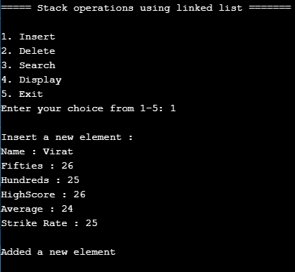
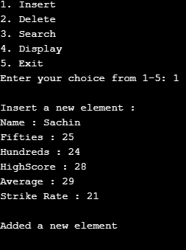
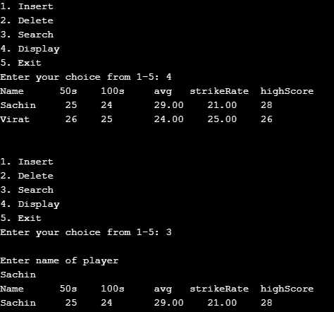
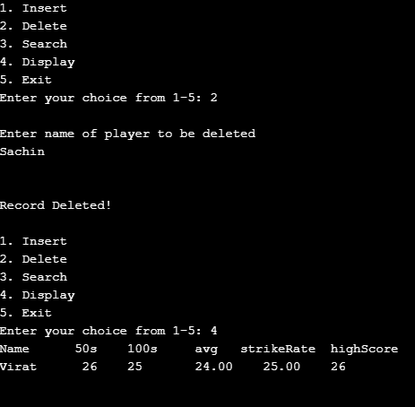
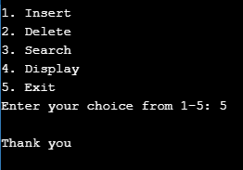
Results: A C program depicting the correct behaviour of array of structure and capable of handling all possible exceptional conditions and the same is reflecting clearly in the output.
Outcomes:Explain the different data structures used in problem solving.

Conclusion: We implemented a C program to create a roll call list of a class using array of structure. It has the details of players as average, hundreds and so on.

Grade: AA / AB / BB / BC / CC / CD /DD
Signature of faculty in-charge with date _______________________________________________________________________
References:
Books/ Journals/ Websites:
- Y. Langsam, M. Augenstin and A. Tannenbaum, “Data Structures using C”, Pearson Education Asia, 1st Edition, 2002

- Data Structures A Psedocode Approach with C, Richard F. Gilberg&Behrouz A. Forouzan, secondedition, CENGAGE Learning

